# How to deploy project to Google App Engine

## I, Create application on App Engine:

a, Access link bellow to create application:

<https://appengine.google.com/>

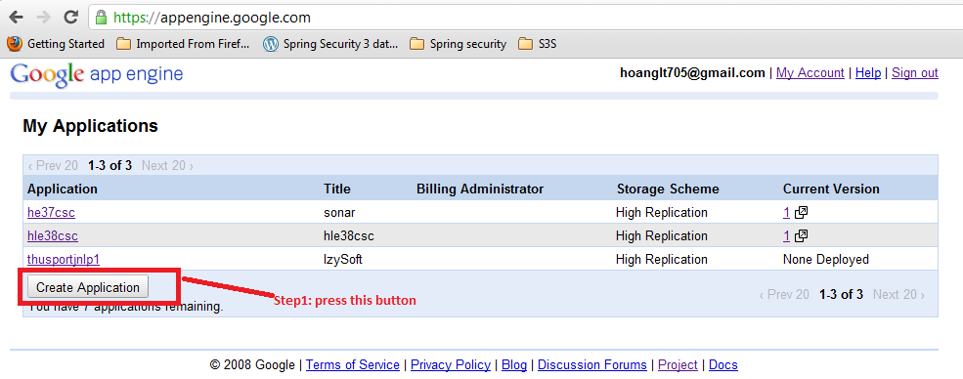

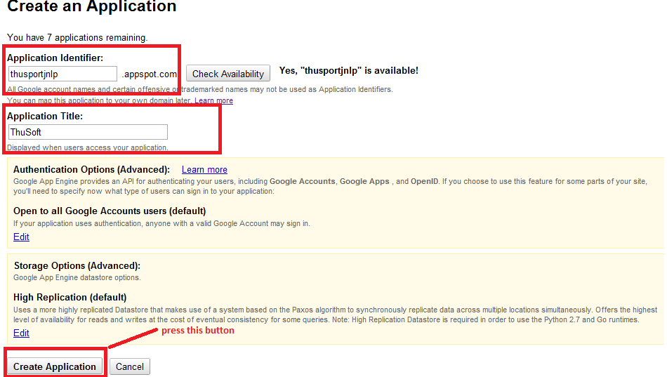

* Note: Remember “Application Identifier” to configure project when you upload application.

b, View Dashboard

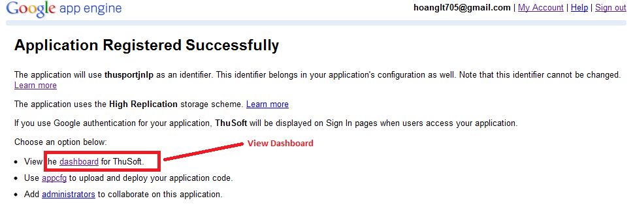

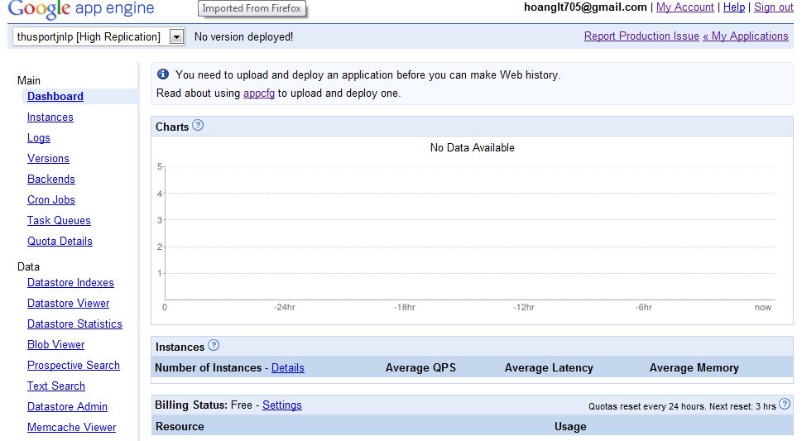

## II, Deploy application:

#### 1, Eclipse:

a, Install plugin Google for Eclipse

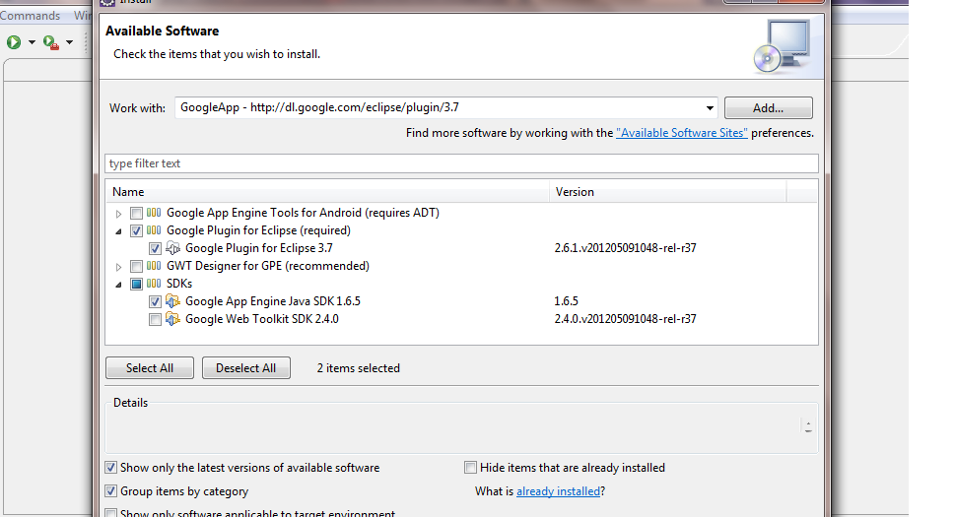

Sign in to Google:

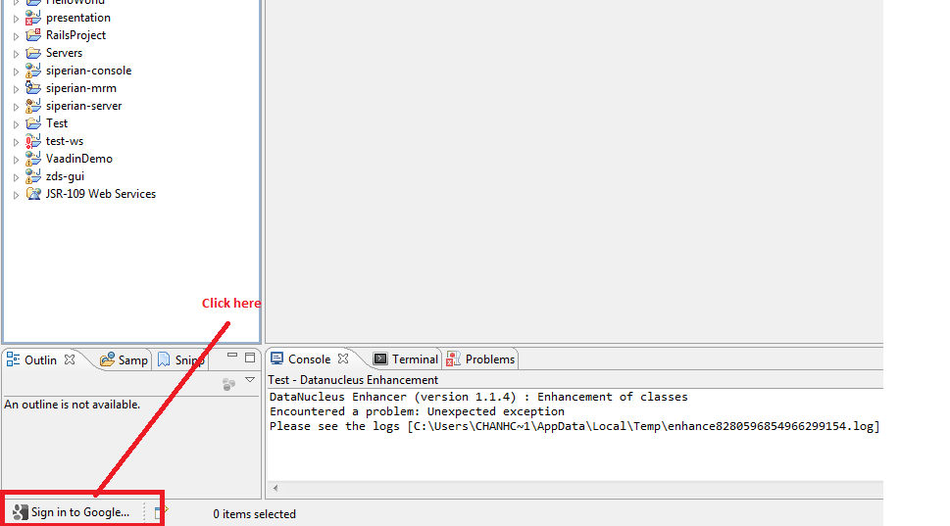

b, Create Web App project:

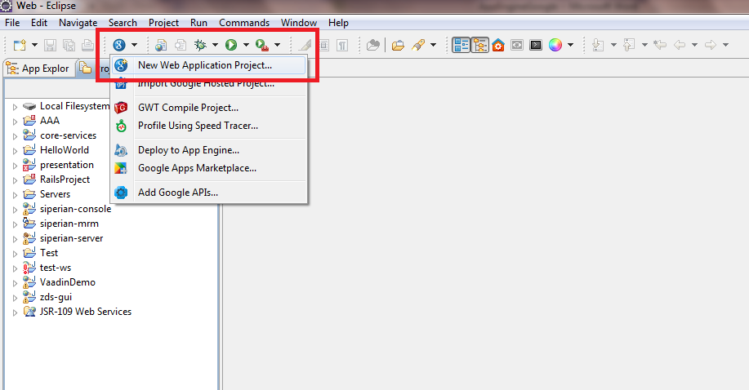

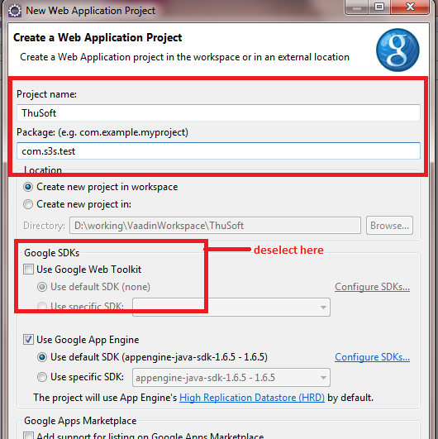

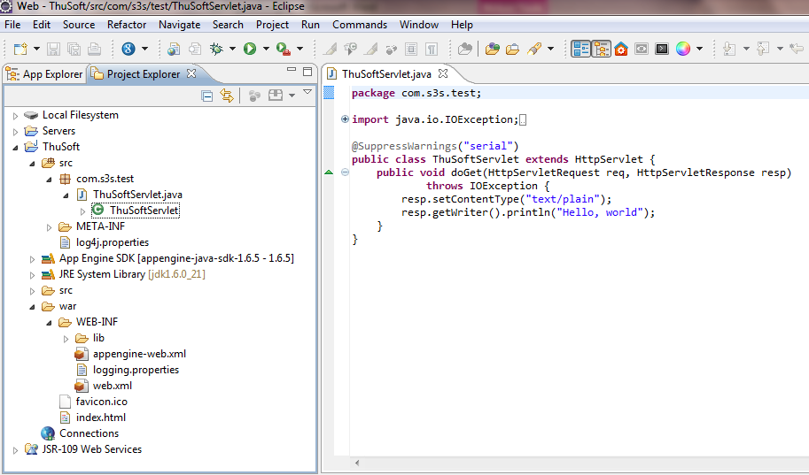

c, Edit “appengine-web.xml”

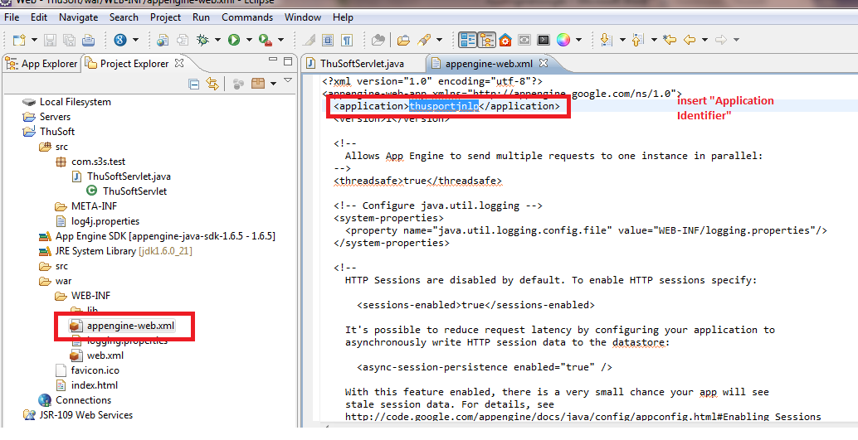

Please refer the Note when we create Application to get “Application Identifier” above.

* Deploy project to App Engine.

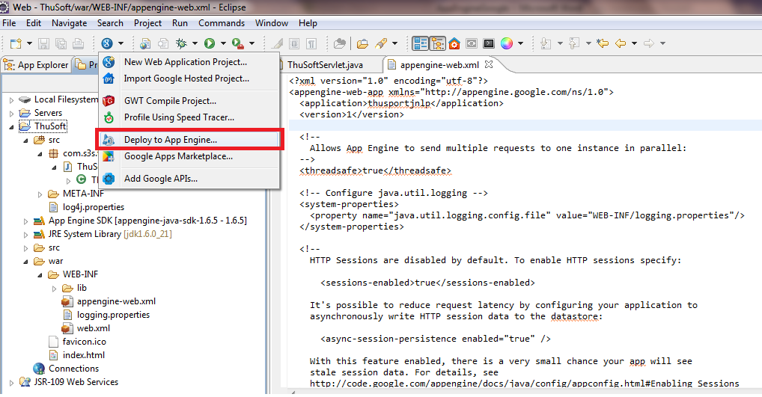

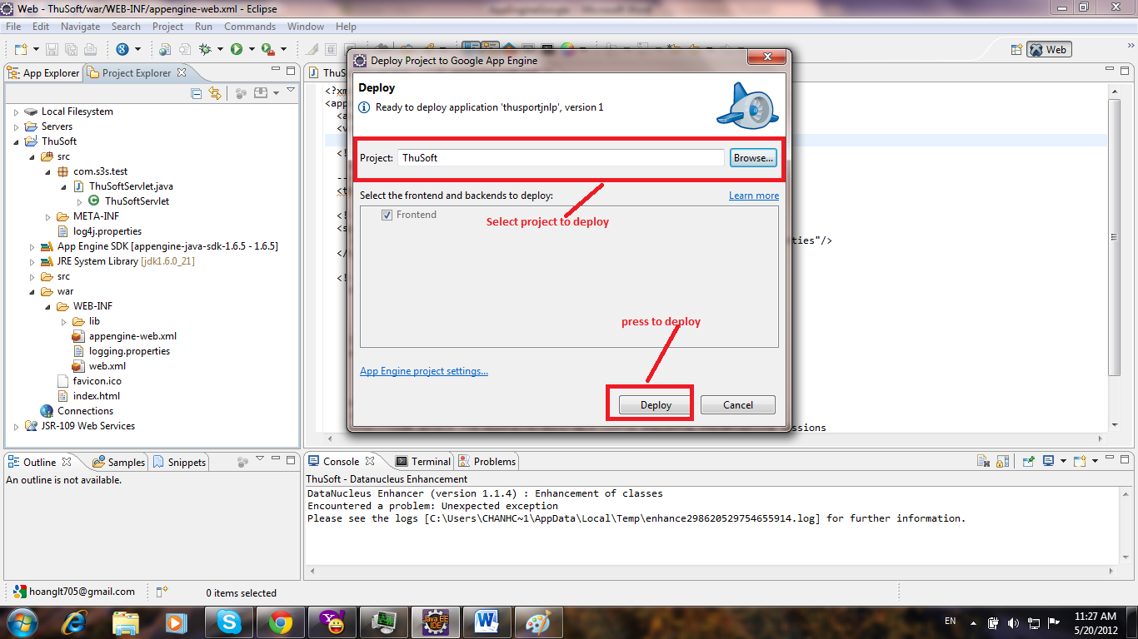

d, Deploying screen

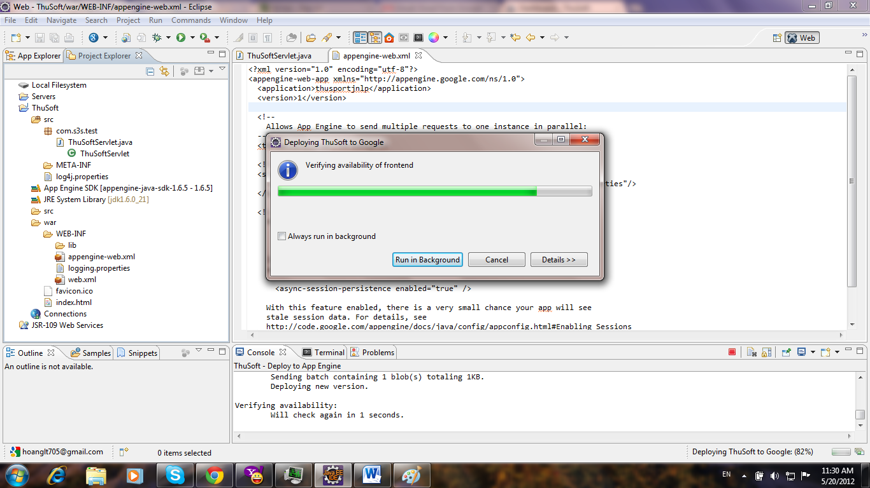

Finish deployment

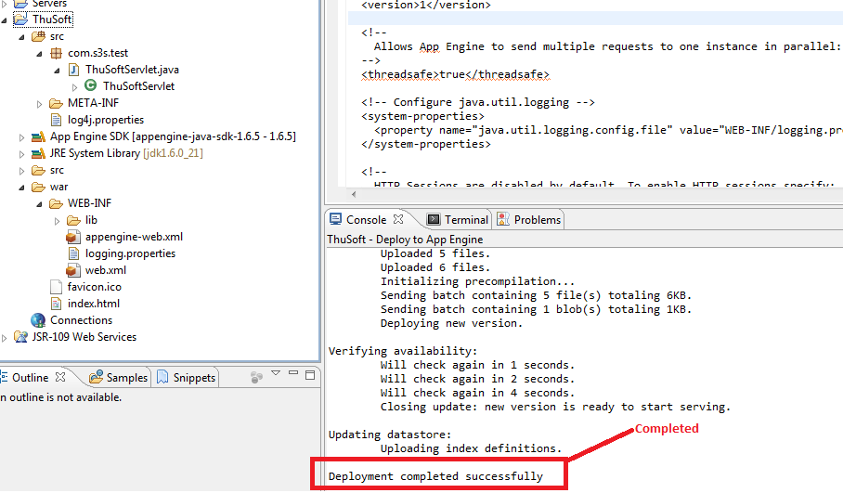

e, Access the project deployed

<thusportjnlp.appspot.com/>

Note: Link = “Application Identifier” + “.appspot.com”

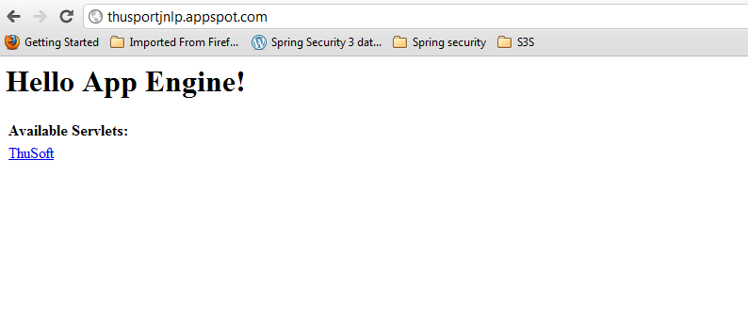

==============================Finish=======================================